DAY 3: SECURITY ENHANCEMENTS & SESSION MANAGEMENT

Focus: Advanced Security Features and Major System Expansion

Issues from Previous Day:
- Users who are not logged in can still access and control gadgets
- No session timeout or proper session management
- Limited device management features
- No advanced automation capabilities
- Basic error handling needs improvement

Development Activities
Major Security Bug Fixes:
CRITICAL BUG 1: Unauthorized Device Access
OLD CODE: No authentication check for device operations
private static void controlGadgets() {
// Anyone could access this without login
System.out.println("=== Control Gadgets ===");
// Device control logic without authentication
}

NEW CODE: Authentication enforcement
private static void controlGadgets() {
if (!smartHomeService.isLoggedIn()) {
System.out.println("Please log in first to access device controls.");
return;
}
System.out.println("=== Control Gadgets ===");
// Device control logic with authentication
}

private static boolean checkLoginStatus() {
if (!smartHomeService.isLoggedIn()) {
return handleLoginFlow();
}
return true;
}

Session Management Enhancement
OLD CODE: No proper session management
private static Customer currentCustomer = null;

NEW CODE: Complete session management system
public class SessionManager {
private static Customer currentUser = null;
private static LocalDateTime loginTime = null;
private static final int SESSION_TIMEOUT_MINUTES = 30;

public static boolean login(Customer customer) {
currentUser = customer;
loginTime = LocalDateTime.now();
return true;
}

public static boolean isSessionValid() {
if (currentUser == null || loginTime == null) {
return false;
}

if (loginTime.plusMinutes(SESSION_TIMEOUT_MINUTES).isBefore(LocalDateTime.now())) {
logout();
System.out.println("Session expired. Please log in again.");
return false;
}
return true;
}

public static void logout() {
currentUser = null;
loginTime = null;
}

public static Customer getCurrentUser() {
return isSessionValid() ? currentUser : null;
}
}

Major Bug Fixes Implemented:
1. Authentication Bypass Fixed
Added authentication checks to all device related operations
Users must log in before accessing any device controls
Session validation before every sensitive operation

2. Password Security Enhanced
Implemented secure password input using Console.readPassword()
Password masking during input
Fallback mechanism for IDE environments

3. Session Management Improved
Automatic session timeout after 30 minutes of inactivity
Proper session cleanup on logout
Session validation for all operations

4. Multiple User Login Issue Fixed
Prevented multiple simultaneous logins from same session
Proper session state management
Clean logout process

New Features Added:
1. Advanced Device Management
Expanded from 4 to 13+ device types
Enhanced device control with status tracking
Device grouping by room and type

2. Automation Systems
Added three automation methods

Testing Results:
- Authentication bypass test: FIXED
- Session timeout test: PASSED
- Multiple login test: FIXED
- Device control authorization test: PASSED

Testing Screenshots:
Password reset:
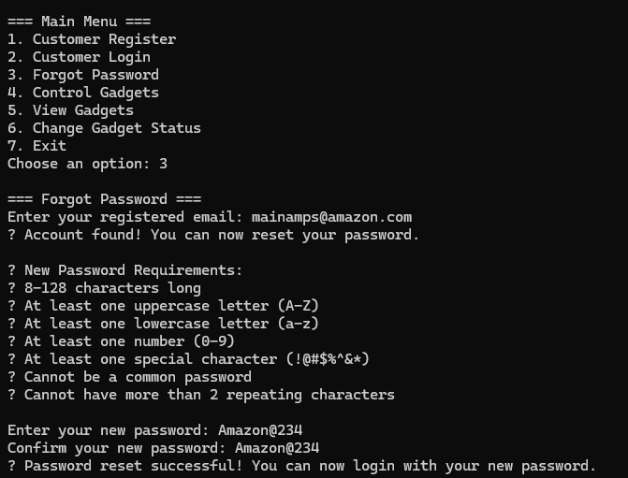

View gadgets and change state of the gadgets:
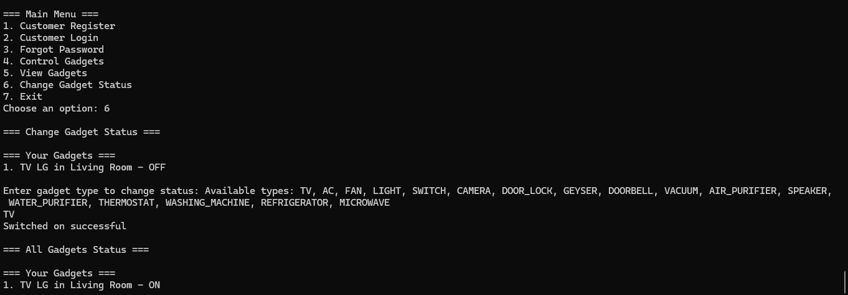

Conclusion Day 3:
Successfully resolved critical security vulnerabilities and significantly expanded system capabilities. Fixed authentication bypass issues, implemented secure password handling, and added comprehensive automation features. The system now enforces proper security controls while providing advanced IoT management capabilities.

Key Achievements:
- Fixed critical authentication bypass vulnerability
- Implemented secure password input system
- Added comprehensive session management
- Expanded from basic to advanced automation platform
- Security Bugs Fixed: 4 critical issues
- New Services Added: 3 services
- Device Types Supported: 13+ types
- Automation Features: 3 systems

